Contents

1 Hot Keys and Controls 1

2 After extruding a shape, it will create a new edge (because the extrude basically adds the shape desired to the old one. 1

3 Subdivision 2

# 1 Hot Keys and Controls

* Right Click: **Click:** Select -------- **Hold:** move selected object
* Middle Mouse: move camera
* Left click: Move XYZ thing
* **Single Key Keyboard Input:**
* A: Select All (depends on if faces, edges, or points are selected in edit mode)
* B: Box Select: this will select all points IN VIEW that are selected. Make it solid first…
* C: Circle Select: This will change the cursor into a circle to select objects.
* E: Extrude (moves selections out or in based on location paramters)
* G: Grab: this allows you to attach a selection to a given axis when moving (hit X,Y, or Z after G)
* P: Separation tool: this allows you to separate selected points from their object c
* R: Rotate (…. Rotate the selection. Note: it rotates on the pivot (i.e. the cursor spot)
* S: Scale (… it scales the selection – enter value or use mouse)
* W: Special Menu (subdivide, rotate, merge, etc.)
* X: Delete (usually will prompt with what part of the selected item you want to delete)
* Escape: Just escapes whatever menu or render option you opened/started
* **Shift + Keyboard Input:**
* Shift + Right Click: Select Multiple Items
* Shift + Middle Mouse Button: Move the viewpointa
* Shift + D: Duplicate a selection
* **Control + Keyboard Input:**
* Ctrl + A: Mesh Menu (adding shapes and stuff)
* Ctrl + S: Selection Tool (quick way to select parts of the screen
* Ctrl + Z: Undo
* **F Keys:**
* F12: Quick render

# 2 Menu’s and Quick Notes

* **Note: You can move these menu’s literally anywhere and duplicate as many windows as you want. You can change the view by just selecting the drop down and then the option you want:**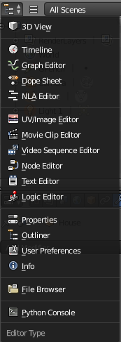
* **The following notes are just the ones I use the most out of the above options:**
* 3D View
  + This view is where all the editing on the object actually takes place
  + You can add, alter, change the view, all kinds of things from this menu
  + I usually have this as my main window
* Outliner
  + This is basically the ‘layer’ view of photoshop – you can delete, select, change arrangement, etc. of each layer. This also keeps your project clean.
* Properties
  + This is how you can apply any direct properties, such as making an object emit light…
* **Quick Notes:**
* For any menu, if you want to make a copy or just a new menu, drag the  icon:  
  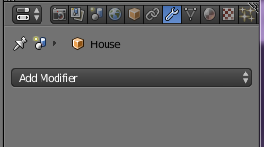 ->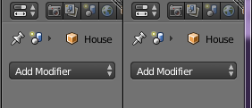
  + To reverse this, drag the icon back over the newly created one:  
    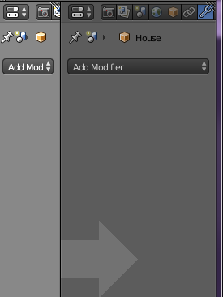

# 3 Moving Objects back to Origin of Grid

* First, select your object and tab into edit mode
* Select the entire object (A)
* Use Shift + S and then select ‘Cursor to Selected’
* Tab into object mode and hit ‘Ctrl + Alt + Shift + C’
  + Select ‘Geometry to Origin’:  
    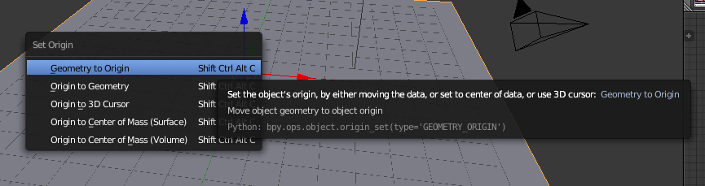
* Then use ‘Shift + S’ again to select ‘Cursor to Center’
* Finally, use ‘Shift + S’ one last time to select ‘Selection to Cursor’

# 4 After extruding a shape, it will create a new edge (because the extrude basically adds the shape desired to the old one.

* In order to delete the old edge, go to the bottom ribbon next to the ‘object/edit’ mode and click on ‘edge select’  
  
* Right click the edge:  
  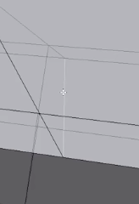
* Hit ‘X’ and then ‘edges’  
  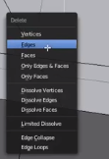

# 5 Subdivision

* The idea of this is to basically make several edges inside a shape. In order to do this, highlight whatever you want to subdivide, then hit ‘W’ and go to ‘SubDivide’:  
  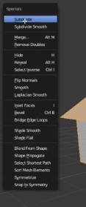
* Once this is done the selection will look like this:   
  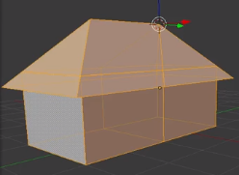 ------>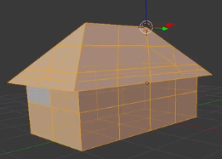
* You can also subdivide the surface using the Modifier’s section:  
  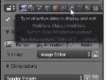
* Once this tab is selected, you can select several modifiers. But we will just select ‘subdivision surface:   
  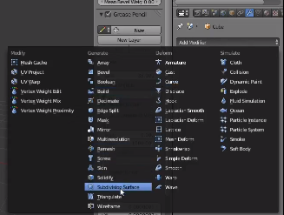
* This will basically round the object – not quite usefull for making doors or windows.. It also appears to work around the edges of the shape. Fewer shapes = smoother object.   
  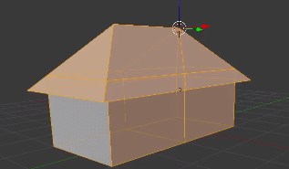 -> 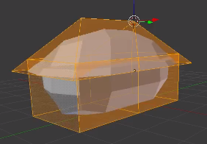
* You can change the amount of subdivisions using the view slider….   
  Lowest: Highest: 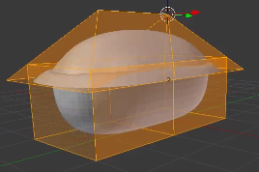

# 6 Doors and Windows

* Using the subdivision method in section 3, it is possible to add windows, doors, or whatever into a shape. First use subdivision in the areas needed (this example just does the entire house):  
  NOTE: **It is usually better to subdivide the entire object instead of just sections of it. This is due to the meshing process that takes place when rendering the object. Note sure if this is true for opengl’s rendering process though.**   
  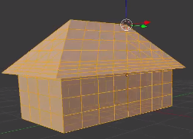
* We will then want to make the object solid instead of transparent:  
    
  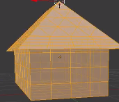 -> 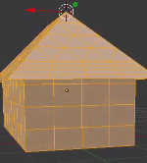
* Switch to the face selection tool:   
  
* Then select the sections you want to turn into a door or window (hold shift and right click)  
  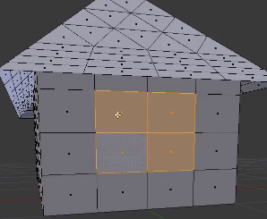
* Use the extrude tool (E) to push or pull the selection. Window’s you would probably want to push…   
  **Note: Whenever this tool is used. You can drag the mouse OR you can just type a number to enter in the value of how much you want it to push/pull. (this is displayed at the bottom left by default)**
* Once you press enter, your extrude will be applied:  
  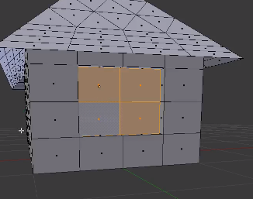

# 7 Adding a Ground

* This is probably the most common thing in any game.. the ground. There are many ways to do this. We will start with the most simplistic method. First, use ‘Shift + S’ to use the snap tool and select cursor to center:  
  **Note: When you add any object, it adds it to where the cursor is…**   
  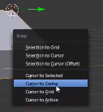 Result: 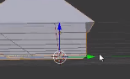
* So, now that the cursor is in the center of the model, we now need add the plane. You can use the tabs on the left like ‘create’ and what not. However, we will use ‘Shift + A’ to open the Mesh menu and select ‘Plane’ (or just hit p)  
  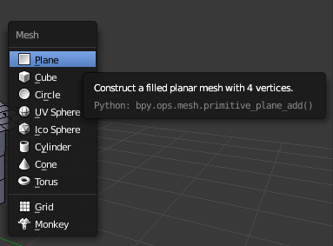
* Now lets scale the object to whatever (hit ‘S’):  
  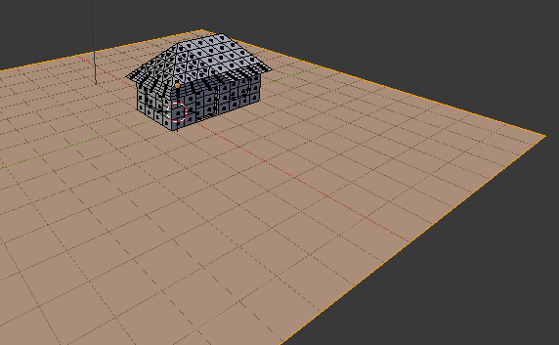

# 8 Adding Light to an Object

* Normally you wouldn’t want to insert a light into a model since lights are handled manually in OpenGL. But for the sake of just showing how its done, go to the Cycles Renderer:  
  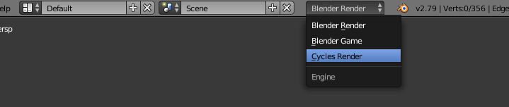
* When you are in the cycles renderer, you can actually create objects to emit light - which is exactly what we are going to do. First, we need to create a normal plane or any object you want to emit light.
* Then, select that object, go to your properties window, and select the material tab. Once this is done, click the ‘New’ button:  
  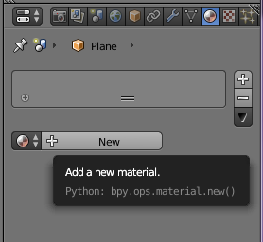
* Then, go to ‘Surface’ -> ‘Surface:’ -> select ‘Emission’ or hit ‘E’:  
  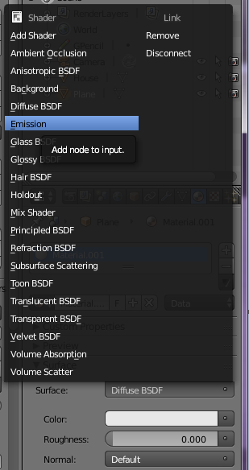 All of those options actually have to do with light.
* You can also change the color to whatever you like. Make sure you put the strength at 10 or so.
* Finally, turn the shape so its actually facing something to shine a light on. I think a circle would emit from all directions?   
  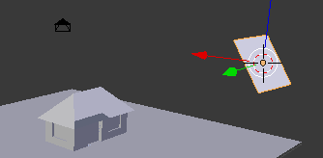
* You can also add more than just one light. This won’t really do anything, though. Ultimately you will be able to see them when using the quick render (f12) to see the light take effect.

# 9 Separating Objects

* There will be a time where you want to apply different materials or properties to different parts of a model. In order to do this, we must separate the object into parts. First, select the area that you want to separate. Note: I used the box tool (B) to select these…   
  **Note: These things MUST be done in edit mode.**  
  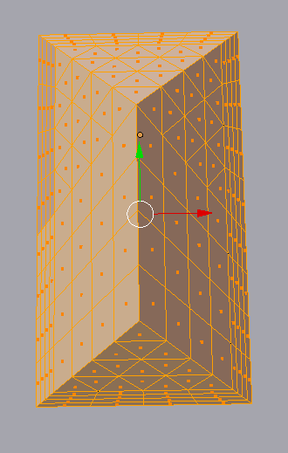
* Now use the separation tool (P) to separate the objects by selection:   
  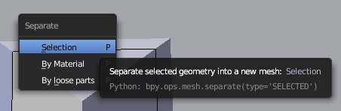
* At this point, itll be separated and now you can rename the object:   
  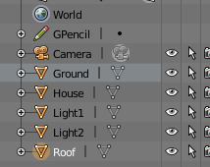

# 10 Working with Material Property

* The material property is found in the properties tab of any object. Essentially, it is how the object should interact with light. (either specular or diffuse).
* The first thing you need to do is select the object, then go to the properties tab and hit material like we did in the light emission tutorial. Then, go ahead and make a new window and set it to the node editor:   
  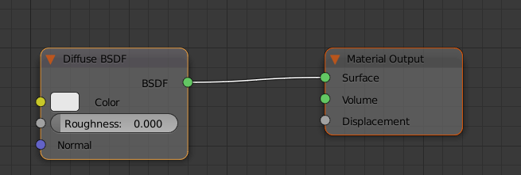
* The node editor is crucial for material options, so get used to using it. It is pretty much only used in the cycles renderer. The ‘material output’ is the final output for the object.

# 11 Texturing Objects

* One of the most important parts of creating a model is the texturing. We are going to cover the quickest way to texture an object inside of Blender. First, create some sort of object.. and select it:  
  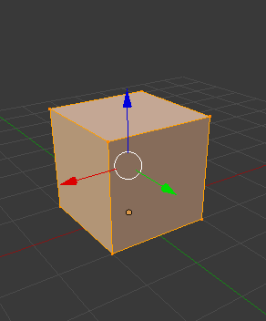  
  **Note: I use three windows for this. The main window is the 3D view. Then on the right side I have two windows. The top is the UV/Image Editor and then the bottom is the node editor.**
* Then, change the view to the cycles render:  
  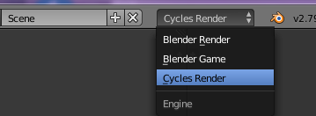
* Then, select the ‘use nodes’ option in the node editor:  
  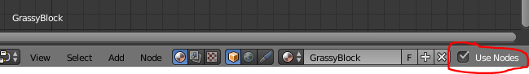
* Then, go to the properties tab, and create a new image. To do this, just type in the name and press enter…   
  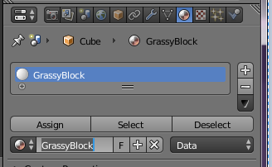
* Now, go to the selected object, press U (unwrap) and select ‘Smart UV’  
  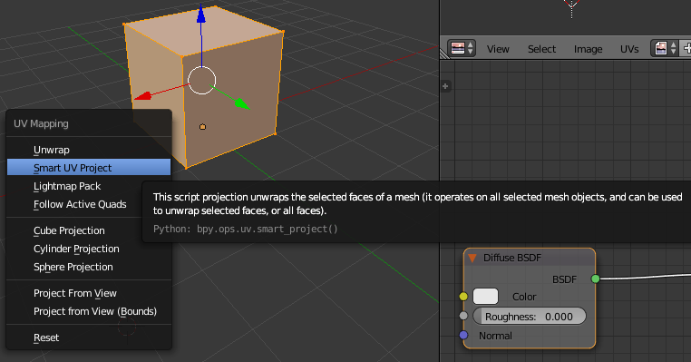  
  **Note: you will need to change the island margin to around 0.09.. (just prevents overlapping in the UV editor)**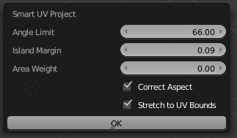
* Once this is done, you should now have the following view:  
  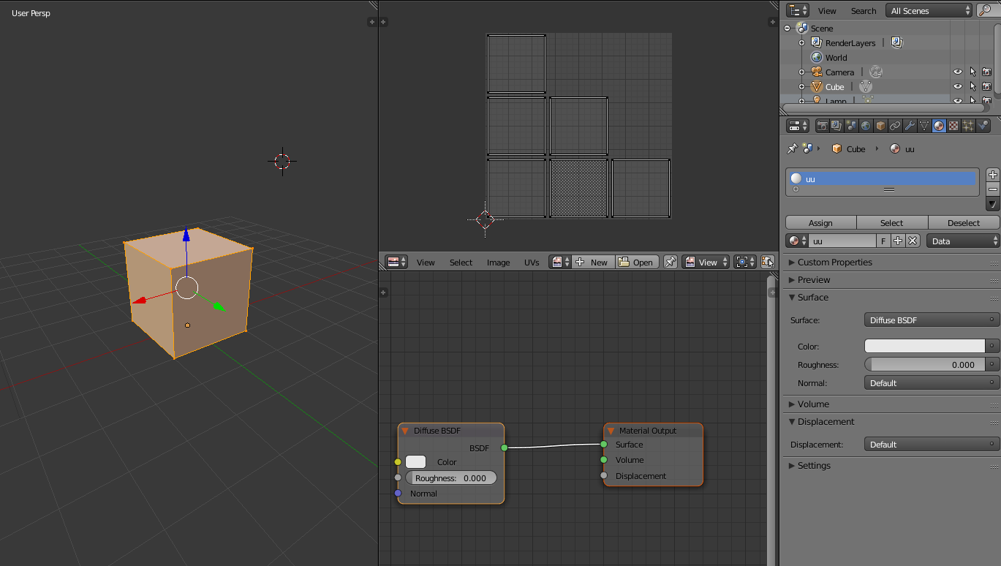
* Now, in the UV editor, select ‘new’ and then type the name and set the resolution of the texture. The UV editor should just be black with the unwrapped sections:  
  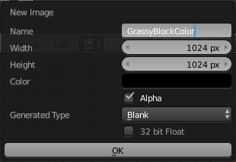 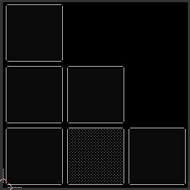
* But, even though this has been done, the new texture still has to be added into the node editor or else nothing will actually happen you try applying paint in the texture paint mode of the 3d view. So, what we need to do is **Add** a new node in the node editor:  
  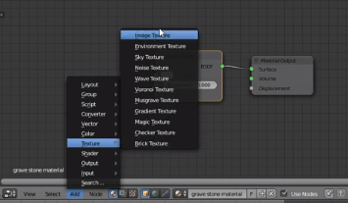 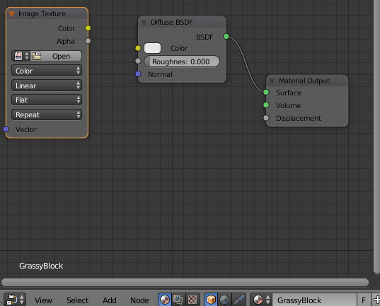
* Essentially, you just created a new layer of texture. You don’t need to link it or anything for now. It is just there and you can select it (as it is now) to edit it. You can also add new textures and edit those without editing any other textures.   
  **NOTE: You still need to save the texture. Blender has its own copy but we don’t actually have a tangible file yet. Go to the UV Editor -> Image -> Save As Image**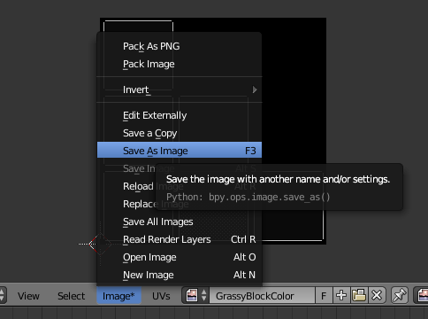
* Once this is done, you should be able to draw however you like!  
  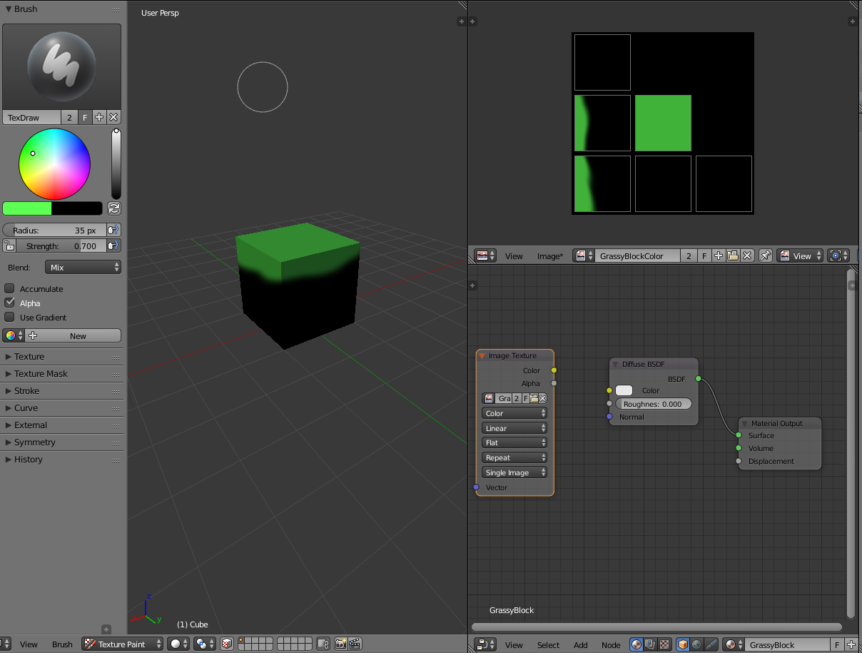  
  **Note: Usually you paint in the 3D View, but you can also paint in the UV editor by changing the mode from view to paint on the bottom right:**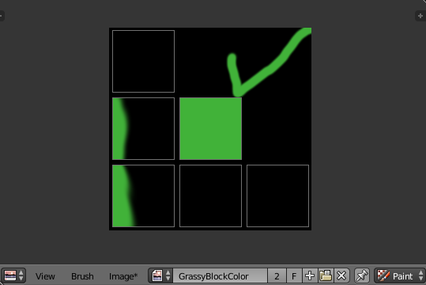

# 12 Exporting the Finished Product

* Alright you have made your object and textured it. Now its time to export the object! Go to File and then export to Wavefront (.obj)  
  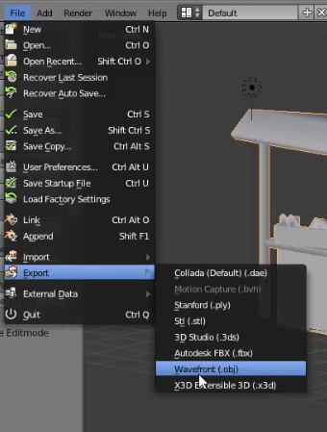
* Before you hit export, make sure the following are selected: Selection Only, Include Normals, Include UVs, Triangulate Faces, and Objects as Obj Objects are checked…   
  Finally, make sure Forward = -Z Forward  
  Up: Y Up ****** Scale: 1.00 ****** Path Mode: Auto  
  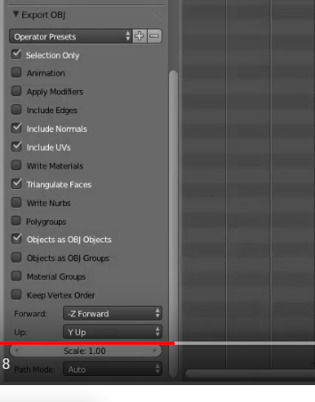Then export!g

# 